WinFrog Configure Settings Guide

- PURPOSE
The purpose of this procedure is to detail the steps involved for all Vessels requiring Winfrog Configuration Settings Guide.

- SCOPE
This procedure applies to all employees within the Organization.

- RESPONSIBILITY AND AUTHORITY
The Technical Director has the responsibility and authority for ensuring that this procedure is effectively implemented.

- Procedure
  - Open Configure “Geodetics”. See Figure 1.

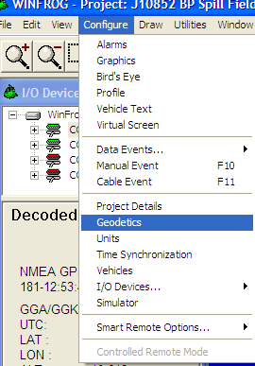
Figure 1

  - Verify General Projection and Specific Projection are set correctly per zone. See Figure 2.

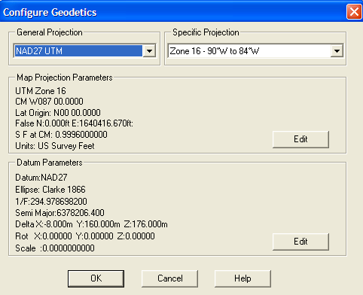
Figure 2

  - Verify “Units” are set. See Figures 3-6.

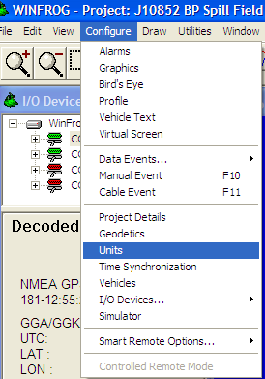
Figure 3
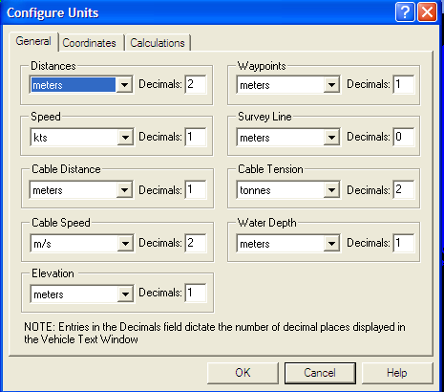
Figure 4

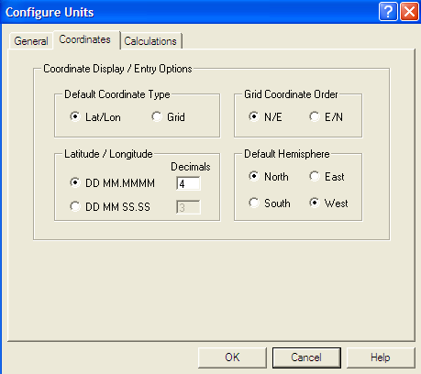
Figure 5

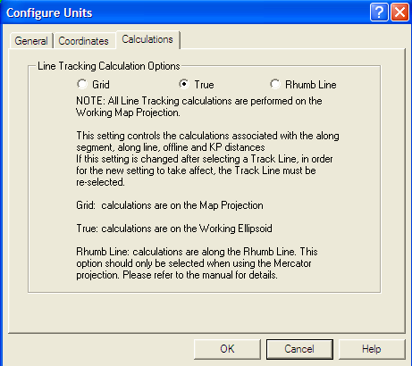
Figure 6

  - Verify “Time Synchronization” is set. See Figures 7 & 8.

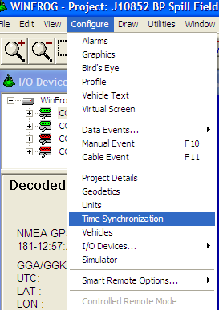
Figure 7

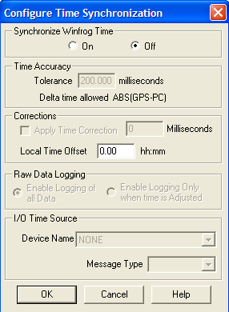
Figure 8

  - Verify Simulator setting. See Figures 9 & 10.

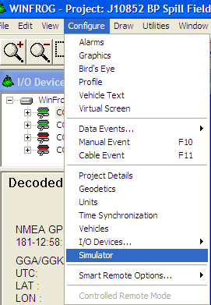
Figure 9
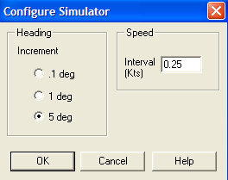
Figure 10

  - Verify “Printer Setup” > then select “Configure”. See Figures 11 & 12.

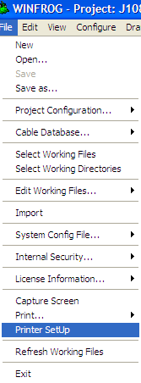
Figure 11

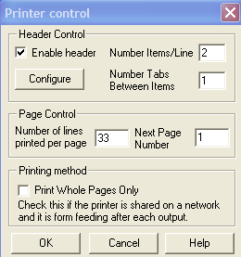
Figure 12

  - Verify Data is correct for Company Name and Vessel > Verify Company Name, Vessel, and Date/Time are checked. See Figure 13.

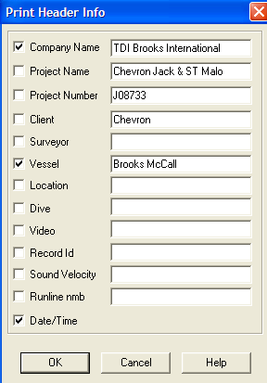
Figure 13

  - Select “Window” and verify and primary screen that “Graphics-1” is selected. See Figure 14.

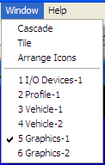
Figure 14

  - Saving/Opening/ or New Projects > See Figure 15.

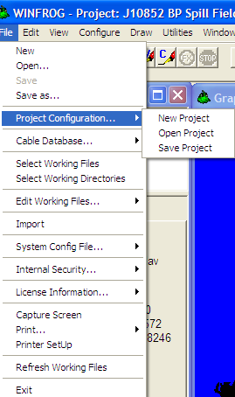
Figure 15

  - For Editing Working files, Waypoints etc. > See Figure 16.

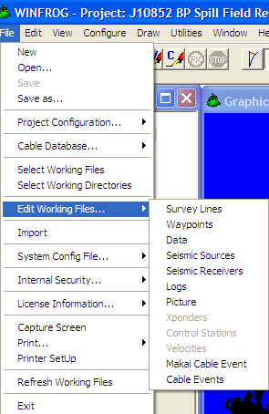
Figure 16

  - Once Configuration file has been modified > Always Save file to continue saving info. See Figure 17.

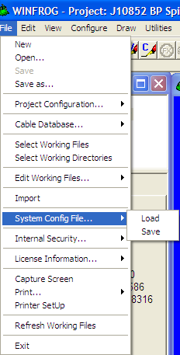
Figure 17

- RELATED DOCUMENTATION

- Revisions

Section | Description | Date | Approved by:
 | Initial Release | 6-30-10 | G. Patterson

